Lab 2 Gui

##### **1. Create a Java project**

Select File -> New -> Java Project, and provide a name to the project, like Lab2_GUI_FX, and a location

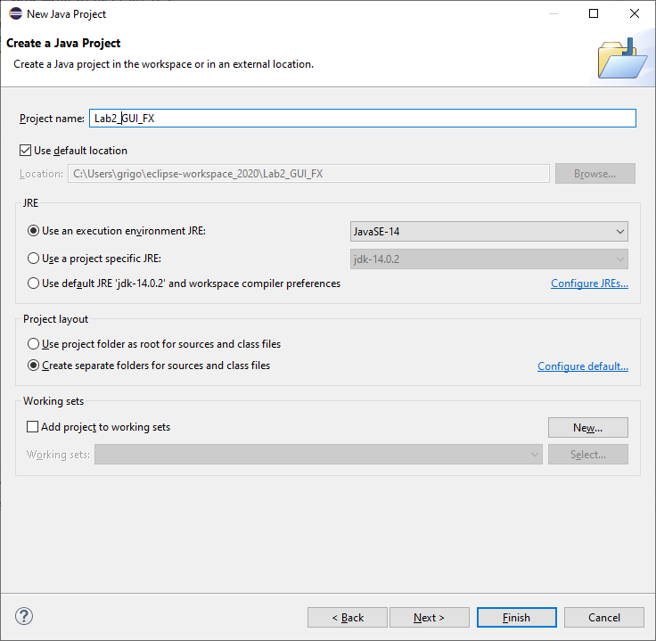

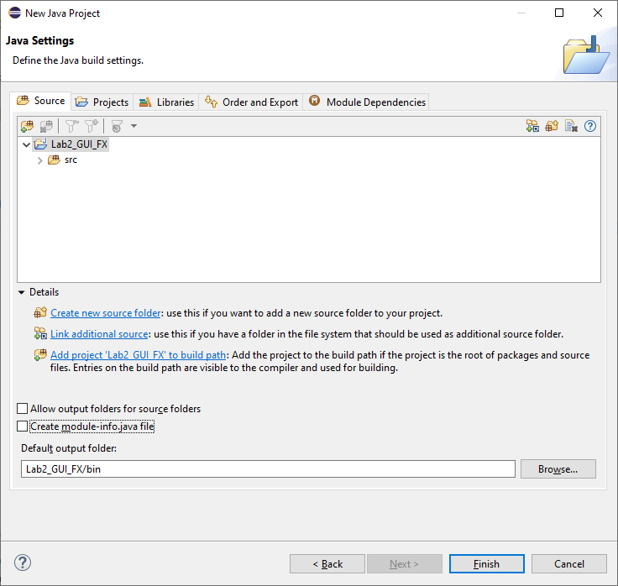

Make sure JDK 15(or 14) or greater is selected. You don't need to add a module-info.java file. You can include the JavaFX15.0.1 library into the classpath.

Click Libraries,

then click Modulepath, then click Add Library, click User Library,

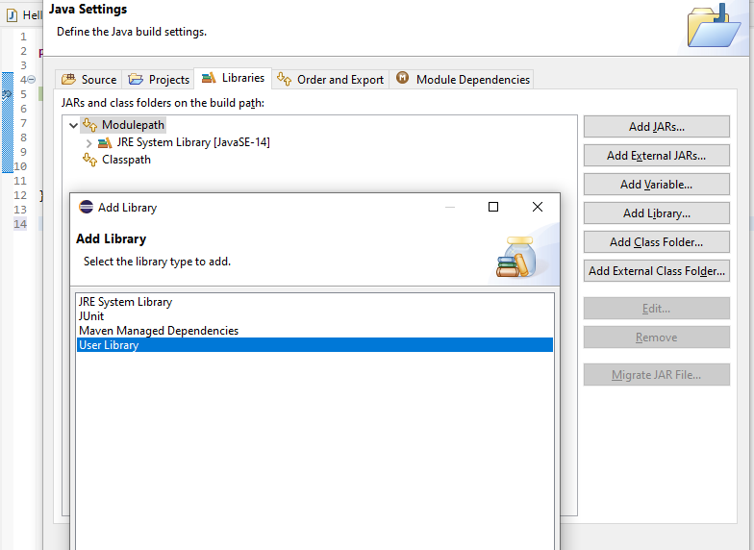

Then click Next,

select JavaFX15 and click Finish

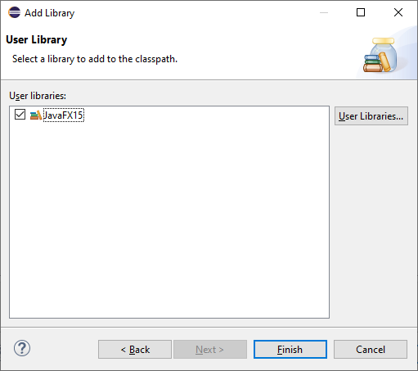

Then click Finish:

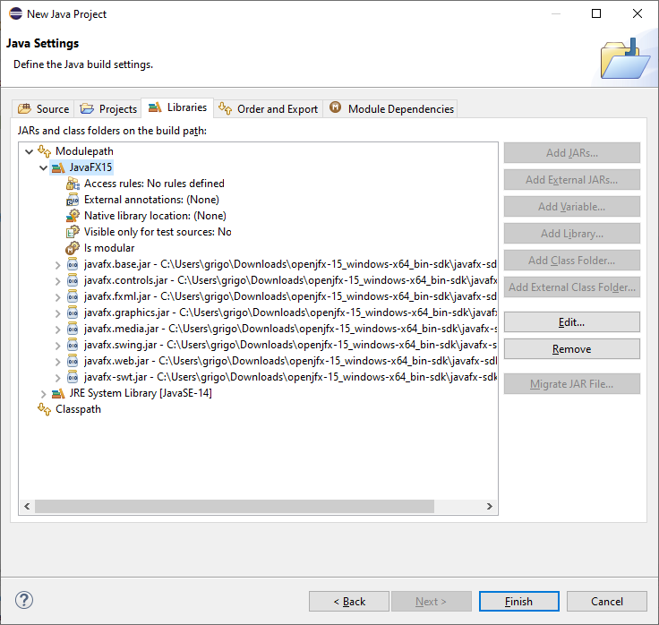

You can click Open Perspective

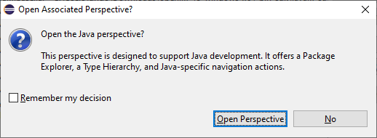

Now you copy and paste your Lab2 Java Files:

Right Click src in your Project Lab2_GUI_FX, and select paste

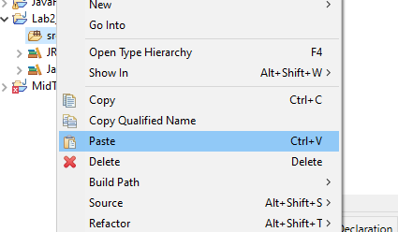

Now you can right click anywhere in your java source code and run your FXDriver.java

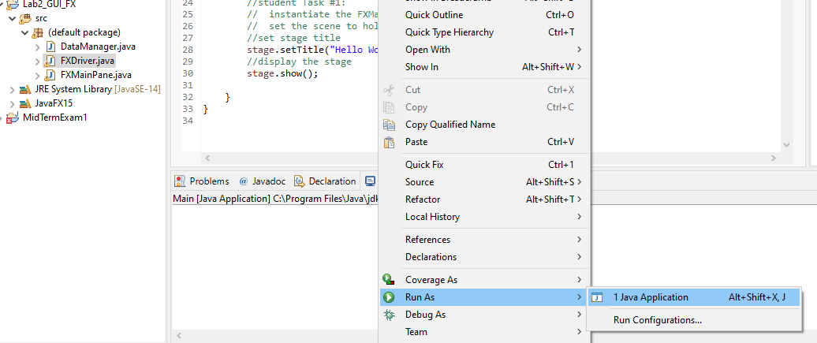

**Warning:**If you now run the project it will compile but you will get this error:

Error: Could not find or load main class FXDriver

Caused by: java.lang.NoClassDefFoundError: javafx/application/Application

##### **3. Add VM arguments**

To solve the issue, click on Run -> Run Configurations... -> Java Application, create a new launch configuration for your project named and add these VM arguments:

Linux/Mac:

--module-path /path/to/javafx-sdk-15.0.1/lib --add-modules javafx.controls,javafx.fxml

Windows:

--module-path /path/to/javafx-sdk-15.0.1/lib --add-modules=javafx.controls

Examples:

--module-path C:\Users\JavaFX_15\javafx-sdk-15.0.1\lib --add-modules=javafx.controls

**Warning:**Make sure the checkbox **"Use the -XstartOnFirstThread argument when launching with SWT"** is not checked.

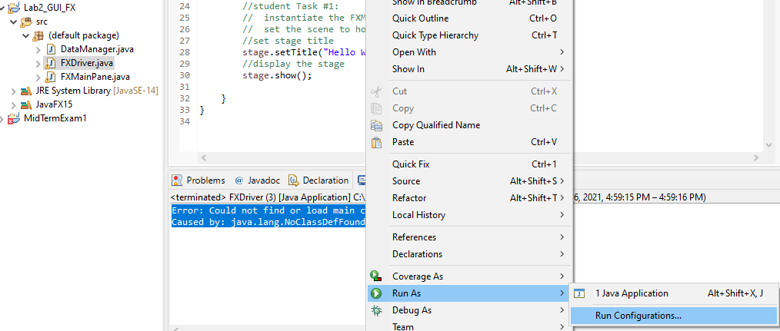

Click Arguments and add VM arguments with your path to javaFX

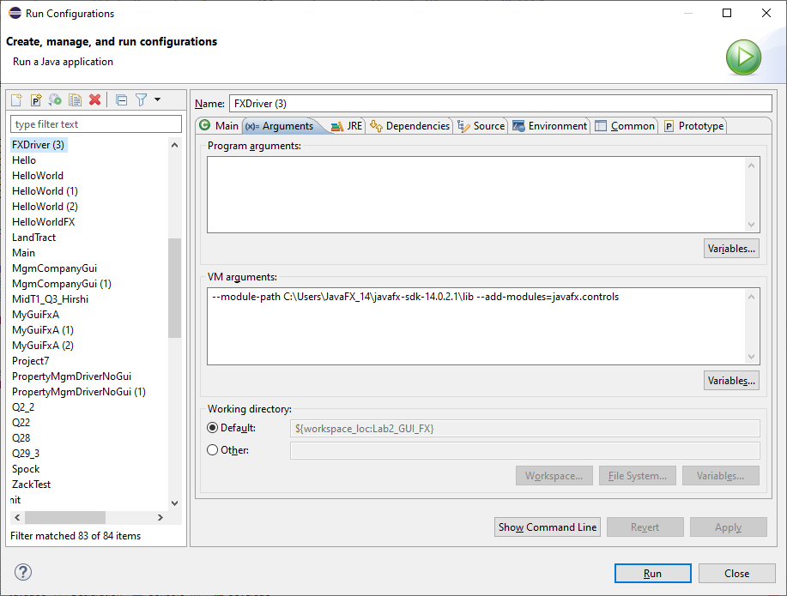

Then click Apply and Run

You can see your run and Gui window:

